Name: ______________________________________ | Date: ___________________

Reading: Anatomy of a Bike Helmet

Have you ever fallen while riding a bicycle? Hopefully you were wearing a helmet! Hitting your head on a hard surface like the road or a sidewalk might result in a serious brain injury. For example, the occipital lobe of your brain, located in the back of your head, is where your vision is processed. A hard blow to the back of your head could leave you with severe vision loss or even total blindness.

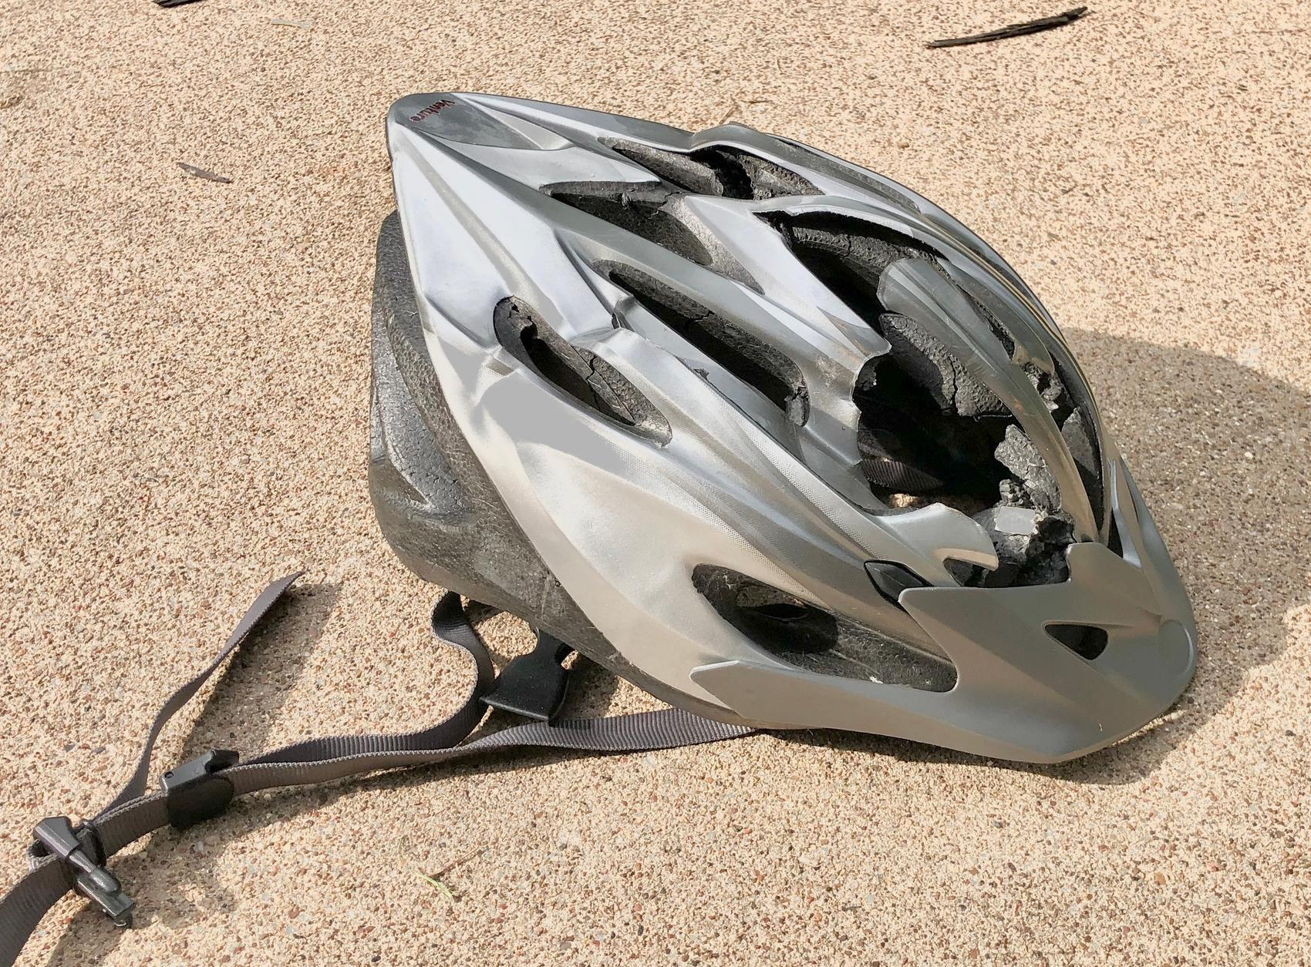 | 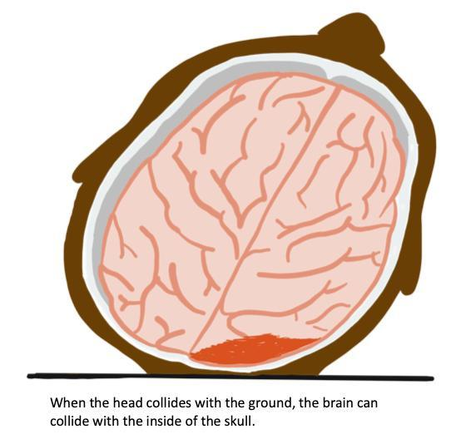
You may remember that long nerve cells called neurons are responsible for your sense of touch and for sending messages to and from your brain and spinal cord. Your brain contains neurons too. You may also remember that neurons send chemical signals from one axon of a cell to another cell to communicate with each other. Neuron activity and connections between neurons in your brain are very important to memory formation.

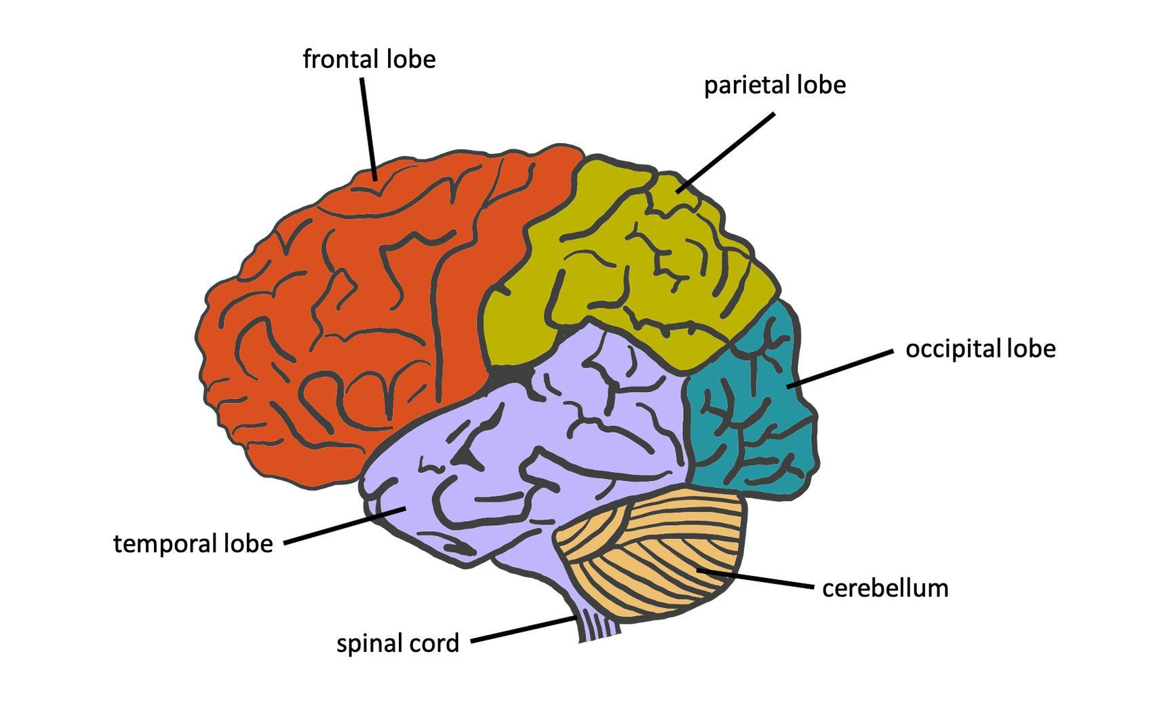 | 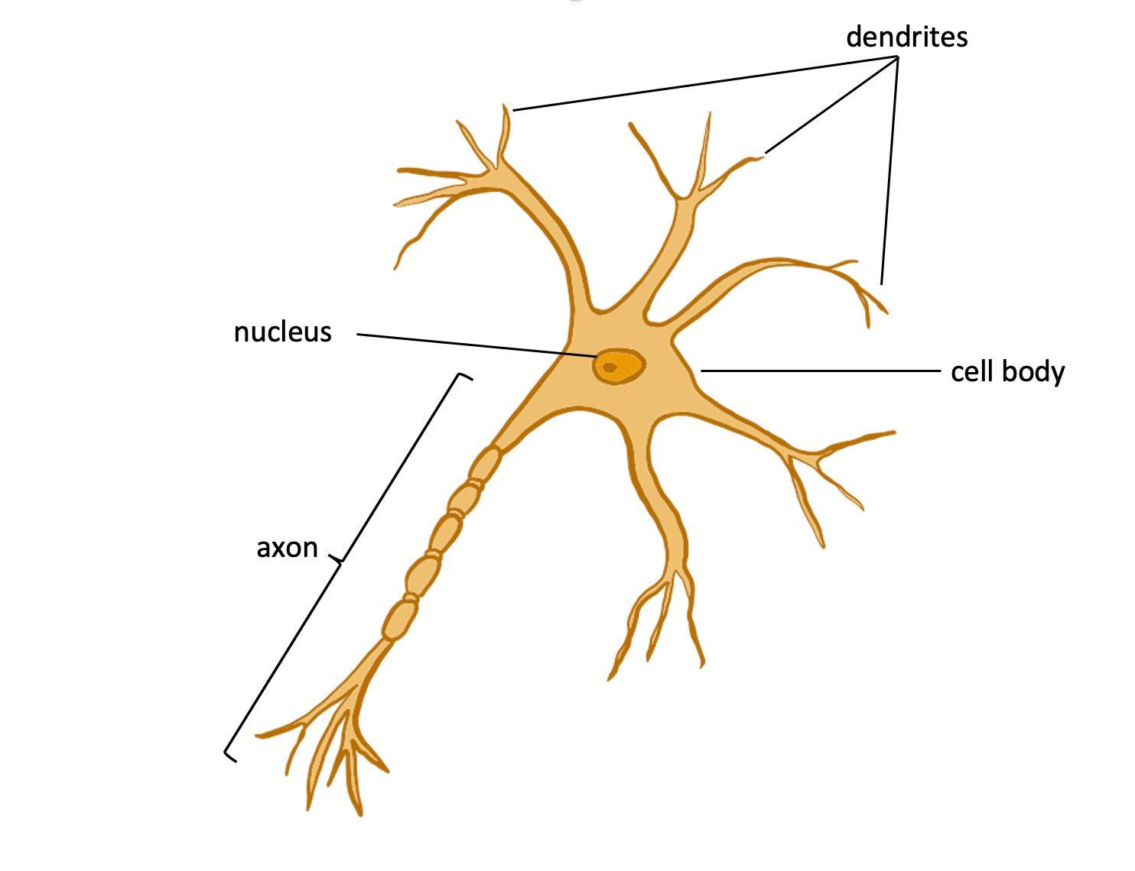
Contact forces to your head can transfer energy to your brain, causing it to twist and collide with the inside of your skull. This can result in a concussion. Contact forces to the brain can cause cell damage. Some effects of cell damage include headaches, trouble concentrating, and memory loss. An impact to the head that causes a concussion can cause the long, connecting nerve cells in the brain to stretch and break. Some nerve cells can recover from injury, but more severely injured cells lose their ability to send signals.

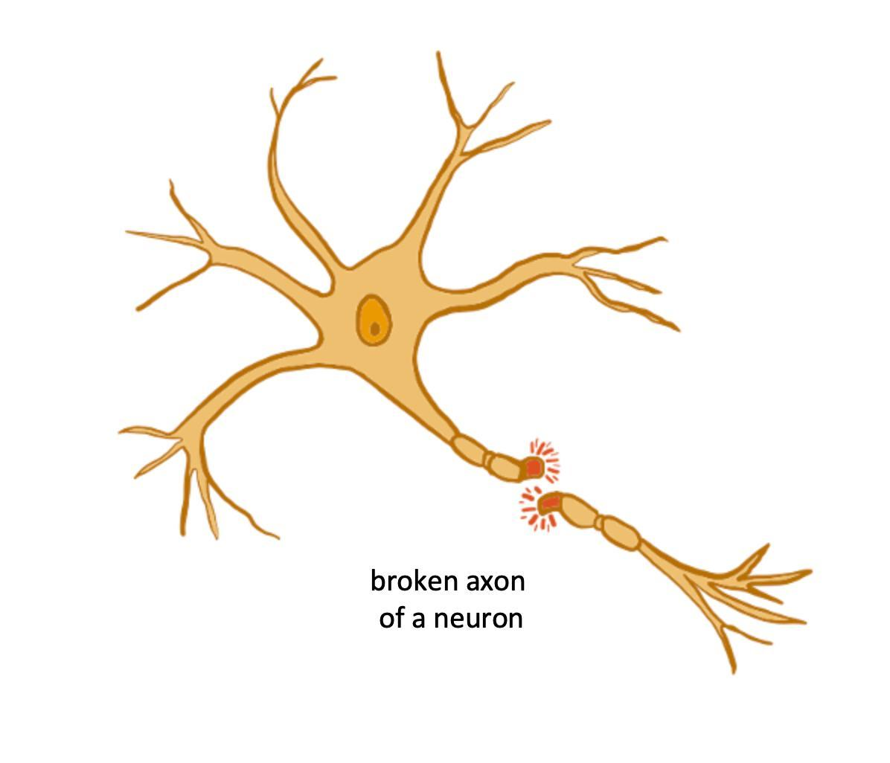
Contact forces to your head can transfer energy to your brain, causing it to twist and collide with the inside of your skull. This can result in a concussion. Contact forces to the brain can cause cell damage. Some effects of cell damage include headaches, trouble concentrating, and memory loss. An impact to the head that causes a concussion can cause the long, connecting nerve cells in the brain to stretch and break. Some nerve cells can recover from injury, but more severely injured cells lose their ability to send signals.

1) How do you think concussions and nerve cell damage can lead to memory loss?

2) What might happen if a person gets multiple concussions?

Wearing a helmet during certain activities, like cycling, can protect your brain from injury and reduce the chance of getting a concussion. You may be wondering why helmets look the way they do. The thickness and shape of all helmets are purposely designed to protect your brain from impact forces caused by collisions. Helmets designed specifically for bicycle riders are important safety gear that can protect your brain. In fact, wearing a helmet can reduce the amount of peak forces on the skull and can lead to a 60% decrease in serious head injuries for riders who hit their heads during falls or accidents.

So what makes a helmet effective? The Consumer Product Safety Commission is the regulating agency in the United States that determines safety standards for many products, including bicycle helmets. There are many choices in helmets, and prices range from very expensive to very affordable. Expensive helmets are not necessarily better. Low-cost helmets that meet the safety standards are good choices for bicycle riders.

When choosing a helmet, you should always make sure that it is approved by the Consumer Product Safety Commission. There are other considerations for helmet manufacturers and bicycle riders, too. A helmet should
- fit snugly and stay in position when you are moving around,
- have easily adjusted straps,
- be lightweight and comfortable, and
- not block your vision in any way.

Companies want helmets to stabilize your head and your brain during a fall. But they also want them to meet the criteria of looking cool so consumers will wear them. Let’s take a look at the structure of a bicycle helmet.

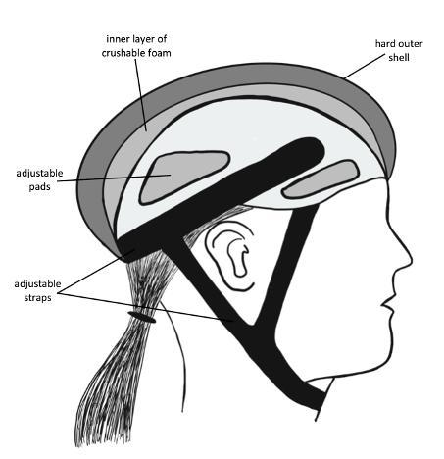
Helmets have hard outer shells made of lightweight materials like polycarbonate or fiberglass. There are often vents in the outer shell to allow air to flow over the cyclist’s head. This hard layer can crack during a collision.

Helmets have an inner layer of crushable foam. The foam has air pockets that are designed to squish during a collision--but not too quickly!

3) Helmets have other design features like adjustable straps and pads to ensure a snug and stable fit for many different head sizes. Why is a snug and stable fit important?

If you have a bicycle helmet that doesn’t meet current safety standards or that doesn’t fit well, you should replace it. You should also replace your helmet if it’s been in a collision because it might not effectively protect you in another collision.

4) Why would small cracks in the outer shell of a helmet make it unsafe?

5) If the inner foam layer of a helmet was crushed in one spot, would the helmet be unsafe?

